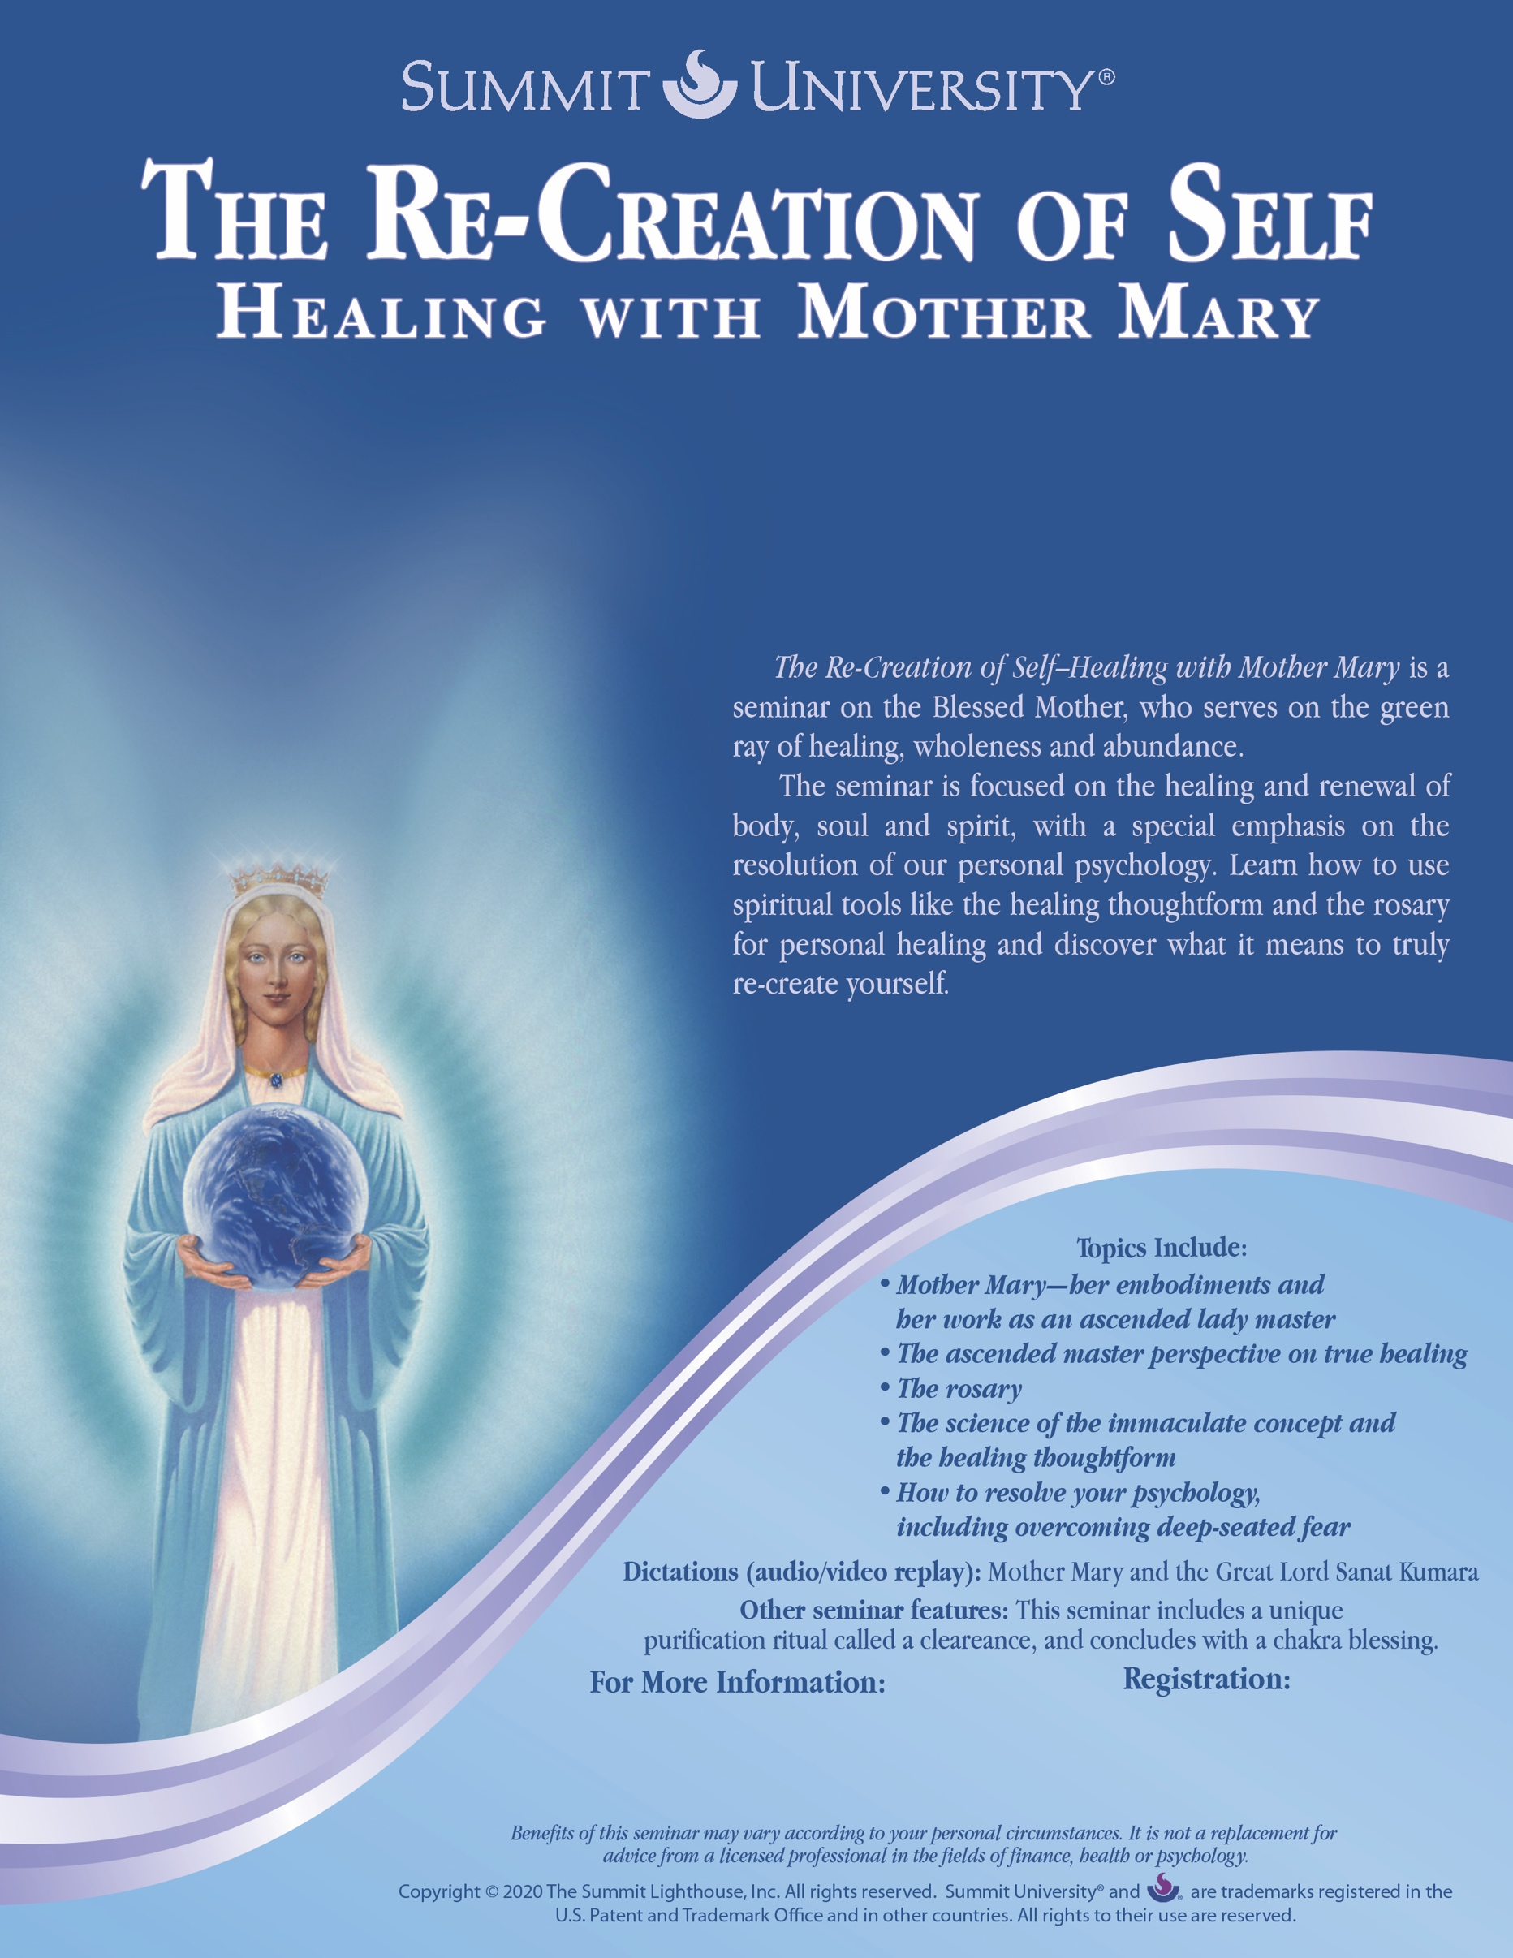

Email: xxx@xxxx.com

Call: (xxx) xxx-xxx

www.xxxx.com

Pre-registration: $___ through

Sunday, October 15

At the door: $____

www.xxxx.com

**October 27-29, 2017**

Friday: 7-9:30pm (registration opens at 6:30pm; Saturday & Sunday: 9am-6pm

**Chicago Community Teaching Center**

2404 Mayfair, Westchester, IL 60154